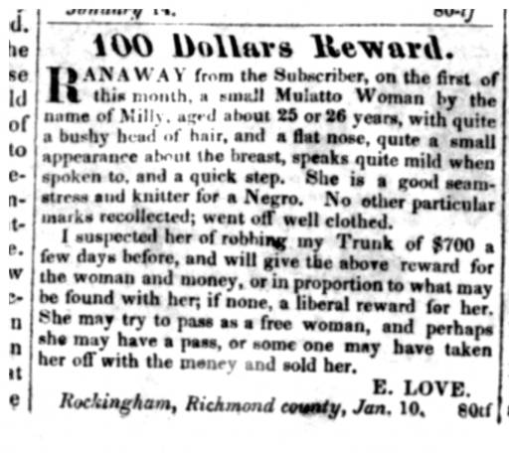

100 Dollars Reward.
RANAWAY from the Subscriber, on the first of this month, a small Mulatto Woman by the name of Milly, aged about 25 or 26 years, with quite a bushy head of hair, and a flat nose, quite a small appearance about the breast, speaks quite mild when spoken to, and a quick step. She is a good seamstress and knitter for a Negro. No other particular marks recollected; went off well clothed.
I suspected her of robbing my Trunk of $700 a few days before, and will give the above reward for the woman and money, or in proportion to what my be found with her; if none, a liberal reward for her. She may try to pass as a free woman, and perhaps she may have a pass, or some one may have taken her off with the money and sold her.
E. LOVE.
Rockingham, Richmond county, Jan. 10. 80tf

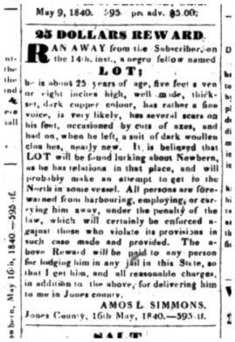
25 DOLLARS REWARD.
RAN AWAY from the Subscriber, on the 14th. inst., a negro fellow named
LOT;
he is about 25 years of age, five feet seven or eight inches high, well made, thick set, dark copper colour, has rather a fine voice, is very likely, has several scars on his feet, occasioned by cuts of axes, and had on, when he left, a suit of dark woollen cloathes, nearly new. It is believed that LOT will be found lurking about Newbern, as he has relations in that place, and will probably make an attempt to get to the North in some vessel. All persons are forewarned from harbouring, employing, or carrying him away, under the penalty of the law, which will certainly be enforced against those who violate its provisions in such case made and provided. The above Reward will be paid to any person for lodging him in any jail in this State, so that I get him, and all reasonable charges, in addition to the above, for delivering him to me in Jones county.
AMOS L. SIMMONS.
Jones County, 16th May, 1840.--595 tf.

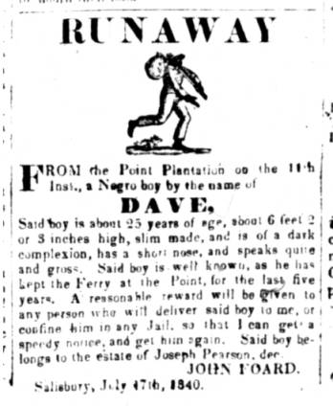
RUNAWAY
FROM the Point Plantation on the 11th Inst., a Negro boy by the name of
DAVE,
Said boy is about 25 years of age, about 6 feet 2 or 3 inches high, slim made, and is of a dark complexion, has a short nose, and speaks quite and gross. Said boy is well known, as he has kept the Ferry at the Point, for the last five years. A reasonable reward will be given to any person who will deliver said boy to me, or confine him in any Jail, so that I can get a speedy notice, and get him again. Said boy belongs to the estate of Joseph Pearson, dec.[deceased]
JOHN FOARD.
Salisbury, July 17th, 1840.

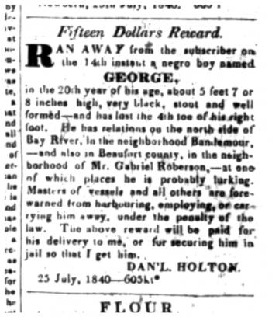
Fifteen Dollars Reward.
RAN AWAY from the subscriber on the 14th instant a negro boy named
GEORGE,
in the 20th year of his age, about 5 feet 7 or 8 inches high, very black, stout and well formed--has lost the 4th toe of his right foot. He has relations on the north side of Bay River, in the neighborhood Bandemour, and also in Beaufort county, in the neighborhood of Mr. Gabriel Roberson, at one of which places he is probably lurking. Masters of vessels and all others are forewarned from harbouring, employing, or carrying him away, under the penalty of the law. The above reward will be paid for his delivery to me, or for securing him in jail so that I get him.
DANIEL HOLTON.
25 July, 1840.

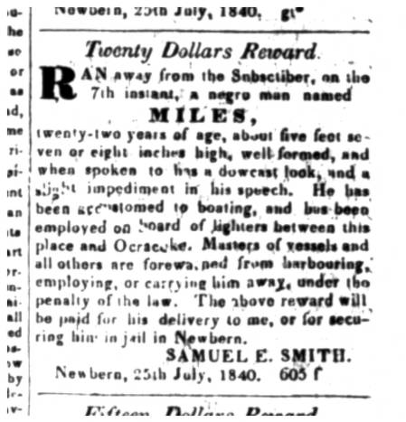Twenty Dollars Reward.
RAN away from the Subscriber, on the 7th instant, a negro man named
MILES,
twenty two years of age, about feet seven or eight inches high, well formed, and when spoken to has a downcast look, and a slight impediment in his speech. He has been accustomed to boating, and has been employed on board of lighters between this place and Ocracoke. Masters of vessles and all others are forwarned from harbouring, employing, or carrying him away, under the penalty of the law. The above reward will be paid for his delivery to me, or for securing him in jail in Newbern.
SAMUEL E. SMITH
Newbern, 25th July, 1840.

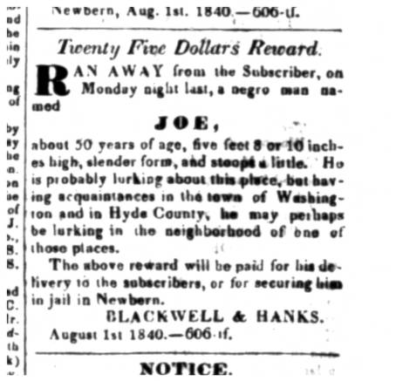

Twenty Five Dollars Reward.
RAN AWAY from the Subscriber, on Monday night last, a negro nam named
JOE,
about 50 years of age, five feet 8 or 10 inches high, slender form, and stoops a little. He is probably lurking about this place, but having acquaintances in the town of Washington and in Hyde County, he may perhaps be lurking in the neighborhood of one of those places.
The above reward will be paid for his delivery to the subscribers, or for securing him in jail in Newbern.
BLACKWELL & HANKS.
August 1st 1840.

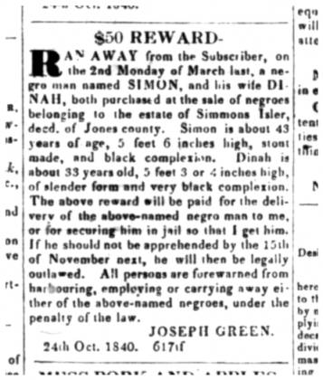$50 REWARD.
RAN AWAY from the Subscriber, on the 2nd Monday of March last, a negro man named SIMON, and his wife DINAH, both purchased at the sale of negroes belonging to the estate of Simmons Isler, decd. of Jones county. Simon is about 43 years of age, 5 feet 6 inches high, stout made, and black complexion. Dinah is about 33 years of old, 5 feet 3 or 4 inches high, of slender form and very complexion. The above reward will be paid for the delivery of the above-named negro man to me, or for securing him in jail so that I get him. If he should not be apprehended by the 15th of November next, he will then be legally outlawed. All persons are forewarned from harbouring, employing or carrying away either of the above-named negroes, under the penalty of the law.
JOSEPH GREEN.
24th Oct. 1840.

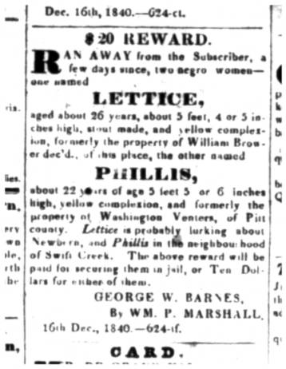
$20 REWARD.
RAN AWAY from the Subscriber, a few days since, two negro women one named LETTICE,
aged about 26 years, about 5 feet, 4 or 5 inches high, stout made, and yellow complexion, formerly the property of William Brower dec'd., of this place, the other named
PHILLIS, about 22 years of age 5 feet 5 or 6 inches high, yellow complexion, and formerly the property of Washington Venters, of Pitt county. Lettice is probably lurking about Newbern, and Phillis in the neighbourhood of Swift Creek. The above reward will be paid for securing them in jail, or Ten Dollars for either of them.
GEORGE W. BARNES
By WILLIAM P. MARSHALL.

TWO HUNDRED DOLLARS REWARD. Ran away from the subscriber, living on the north side of Severn, at the Ferry, about sunrise on the morning of the 25th November, a Negro Man, who calls himself HENRY HAMMOND. He was formerly the property of Dr. Rea, from whose estate I purchased him about four years ago. He is about 29 years of age; about 5 feet 6 inches high; very bright color, but not a mulatto; has a scar from the bite of a dog on one of his legs, which was seared with an iron to prevent hydrophobia. The clothing which he took with him, as far as can be ascertained, was a black cloth body coat, and black pantaloons, not very much worn; and plain black Russian hat. His working clothes, which he had on, are, drab pantaloons, which several patches on them, and drab coat, bull woolly; and a pair of new coarse pegged boots. It is probably that he has a pass bearing the name of Samuel Wilson, (a deceased negro) from whose wife he endeavored to obtain said pass during the last summer.
I will give 200 dollars for apprehension of the above described negro, if he is taken out of the state of Maryland; and if taken in the state I will give $100 if safely lodged in jail or delivered to me.
GEORGE B. HAYDEN
Annapolis, Nov. 25

