What is slavery?
_______________________________________________________________________________________________________________________________________________________________________________________________________________________________________________________________________________________________________________
Picture ONE:
(Solo) Write down two details from the image you find interesting (good or bad).
1)______________________________________________________________________________________________________________________________________________________
2)______________________________________________________________________________________________________________________________________________________
(Solo) How does this image make you feel?
________________________________________________________________________________________________________________________________________________________________________________________________________________________________________________________________________________________________________________

VIDEO ONE:
(Solo then discuss) What is it like to pick cotton?
____________________________________________________________________________________________________________________________________________________________________________________________________________________________________________________________________________________________________________________________________________________________________________________________
(Solo then discuss) Write down one detail from the videos you want to talk about.
____________________________________________________________________________________________________________________________________________________________________________________________________________________________________
READING ONE:
(Solo then discuss) Write down one detail from the reading you want to talk about.
(Work in the Fields)_____________________________________________________________ ________________________________________________________________________________________________________________________________________________________
Picture TWO:
(Solo) Write down two details from the image you find interesting (good or bad).
1)______________________________________________________________________________________________________________________________________________________
2)______________________________________________________________________________________________________________________________________________________
(Solo) How does this image make you feel?
________________________________________________________________________________________________________________________________________________________________________________________________________________________________________________________________________________________________________________
VIDEO TWO:
(Solo then discuss) What is it like to be sold?
____________________________________________________________________________________________________________________________________________________________________________________________________________________________________________________________________________________________________________________________________________________________________________________________
(Solo then discuss) Write down one detail from the video you want to talk about.
____________________________________________________________________________________________________________________________________________________________________________________________________________________________________
READING TWO:
(Solo then discuss) Write down one detail from the reading you want to talk about.
(Slave Auction)_____________________________________________________________ ________________________________________________________________________________________________________________________________________________________
(Solo then discuss) Write down one detail from the reading you want to talk about.
(How Far a Person Will Go)________________________________________________________ ________________________________________________________________________________________________________________________________________________________

Picture THREE:
(Solo) Write down two details from the image you find interesting (good or bad).
1)______________________________________________________________________________________________________________________________________________________
2)______________________________________________________________________________________________________________________________________________________
(Solo) How does this image make you feel?
________________________________________________________________________________________________________________________________________________________________________________________________________________________________________________________________________________________________________________
VIDEO THREE:
(Solo then discuss) What is it like to be punished?
____________________________________________________________________________________________________________________________________________________________________________________________________________________________________________________________________________________________________________________________________________________________________________________________
(Solo then discuss) Write down one detail from the video you want to talk about.
____________________________________________________________________________________________________________________________________________________________________________________________________________________________________
READING THREE:
(Solo then discuss) Write down one detail from the reading you want to talk about.
(Punishment-1)________________________________________________________________ ____________________________________________________________________________
(Solo then discuss) Write down one detail from the reading you want to talk about.
(Punishment-2)________________________________________________________________ ____________________________________________________________________________
(Solo then discuss) Write down one detail from the reading you want to talk about.
(Punishment-3)________________________________________________________________ ____________________________________________________________________________
What is slavery?
____________________________________________________________________________________________________________________________________________________________________________________________________________________________________________________________________________________________________________________________________________________________________________________________________________________________________________________________________________________________________________________________________________________________________________________________________________________________________________________________________________________________________________________________________________________________________________________________________________________________________________________________

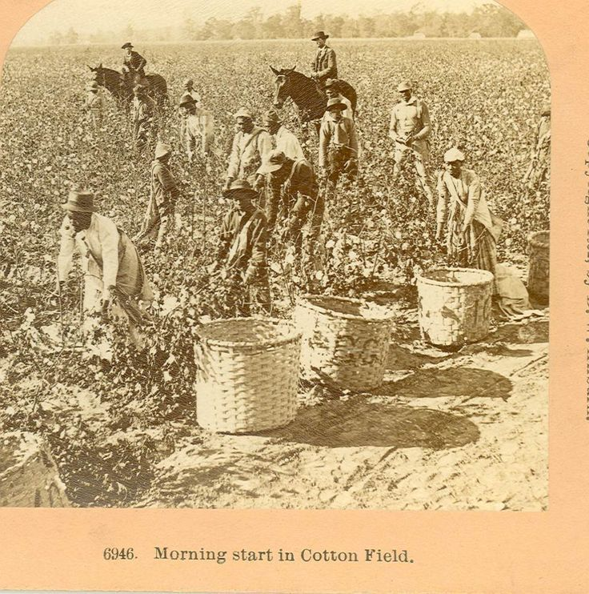
Picture from: https://www.pinterest.com/jmaterne67gmail/cotton-fields/

http://www.youtube.com/watch?v=PDO5oEjTEI0 racist video of fun cotton picking
http://www.youtube.com/watch?v=IW4dBODmN9o Black and white interview
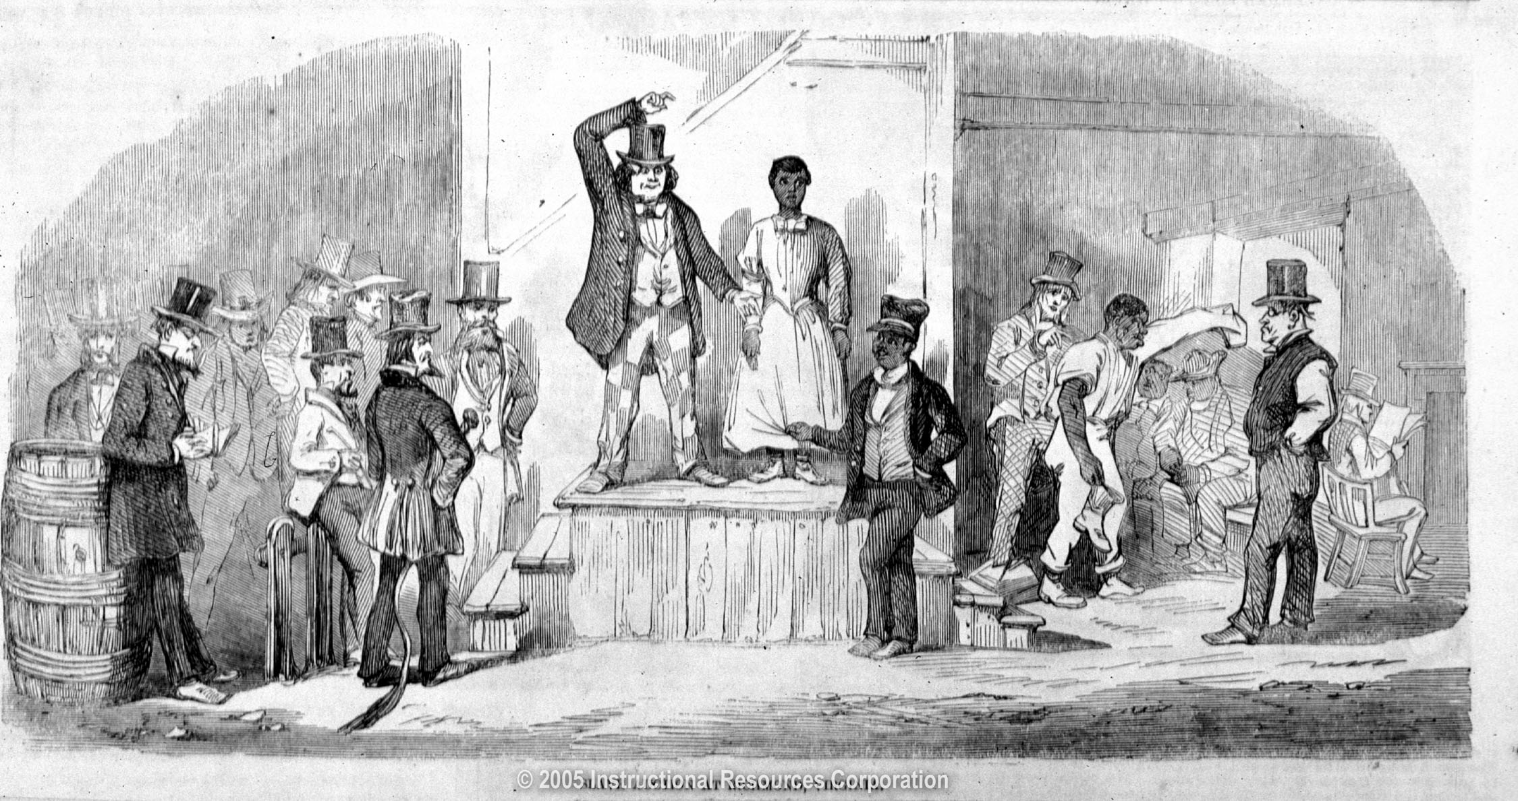
Picture from: http://www.americaslibrary.gov/jb/reform/jb_reform_slaveauc_1_e.html

http://www.youtube.com/watch?v=05jtVXAih-s slave auction

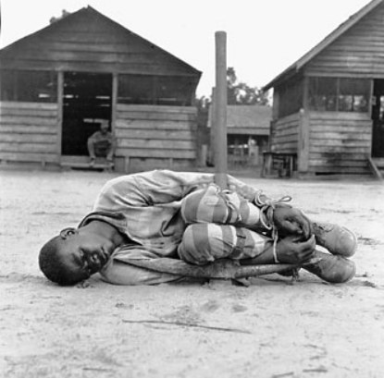
Picture from: https://miscellany101.wordpress.com/2009/10/02/americas-incessant-internal-battle-with-racism/

http://www.youtube.com/watch?v=hjpGklyrIcU Haiti explanation of punishments (start at 30sec)
http://www.youtube.com/watch?v=OU1cbqg6qQg 12 years a slave (scary slavery)

The following accounts of slavery have all been taken from TO BE A SLAVE by Julius Letster
(Work in the Fields)
Blackshear had them take their babies with them to the field and it was two or three miles from the house to the field. He didn’t want them to lose time walking backward and forward nursing. They built a long rough like a great long old cradle and put all these babies in it every morning when the mother came out to the field. It was set at the end of the rows under a big cottonwood tree. When they were at the other end of the row, all at once a cloud no bigger than a small spot came up and it grew fast, and it thundered and lightened as if the world was coming to an end, and the rain just came down in great sheets. And when it got so they could go to the other end of the field, that trough was filled with water and every baby in it was floating round in the water, drowned. They never got nary a lick of labor and nary a red penny for any of them babies.
IDA HUTCHINSON
Library of Congress

The following accounts of slavery have all been taken from TO BE A SLAVE by Julius Letster
(Work in the Fields)
Blackshear had them take their babies with them to the field and it was two or three miles from the house to the field. He didn’t want them to lose time walking backward and forward nursing. They built a long rough like a great long old cradle and put all these babies in it every morning when the mother came out to the field. It was set at the end of the rows under a big cottonwood tree. When they were at the other end of the row, all at once a cloud no bigger than a small spot came up and it grew fast, and it thundered and lightened as if the world was coming to an end, and the rain just came down in great sheets. And when it got so they could go to the other end of the field, that trough was filled with water and every baby in it was floating round in the water, drowned. They never got nary a lick of labor and nary a red penny for any of them babies.
IDA HUTCHINSON
Library of Congress

(Slave Auction)
I went into Charleston. The prices usually went up on slaves in the fall of the year. Along in September what was known as nigger-traders started to coming around Charleston which was a great trading post. When selling time came we had to wash up and comb our hair so as to look as good as we could so as to demand a high price. Oh yes, we had to dress up and parade before the white folks until they picked the ones they wanted. I was sold along with a gang of others to a trader and he took us to Louisiana. There, I believe I was sold to the meanest man that God ever put breath in. Out of seventeen of us sold to him, only four of us got back home. Some died; others be killed.
ANONYMOUS
Fisk, pp. 161-163

(Slave Auction)
I went into Charleston. The prices usually went up on slaves in the fall of the year. Along in September what was known as nigger-traders started to coming around Charleston which was a great trading post. When selling time came we had to wash up and comb our hair so as to look as good as we could so as to demand a high price. Oh yes, we had to dress up and parade before the white folks until they picked the ones they wanted. I was sold along with a gang of others to a trader and he took us to Louisiana. There, I believe I was sold to the meanest man that God ever put breath in. Out of seventeen of us sold to him, only four of us got back home. Some died; others be killed.
ANONYMOUS
Fisk, pp. 161-163

(How Far a Person Will Go)
My mother told me that he owned a woman who was the mother of seven children, and when her babies would get about a year or two of age, he’d sell them and it would break her heart. She never got to keep them. When her fourth baby was born and was about two months old, she just studied all the time about how she would have to give it up, and one day she said, “I just decided I’m not going to let ol’ master sell this baby; he just ain’t going to do it.” She got up and give it something out of a bottle and pretty soon it was dead.
LOU SMITH
Botkin, p. 154

(How Far a Person Will Go)
My mother told me that he owned a woman who was the mother of seven children, and when her babies would get about a year or two of age, he’d sell them and it would break her heart. She never got to keep them. When her fourth baby was born and was about two months old, she just studied all the time about how she would have to give it up, and one day she said, “I just decided I’m not going to let ol’ master sell this baby; he just ain’t going to do it.” She got up and give it something out of a bottle and pretty soon it was dead.
LOU SMITH
Botkin, p. 154

(Punishment-1)
Anytime ol’ massa got a slave that been cuttin’ up or something, he tell Gabe to give that slave a lashin’. Sometime he come down to the barn to watch it, but most time he just se ton the porch and listen to the blows. Ol’ Gabe didn’t like that whipping business, but couldn’t help himself. When massa was there, he would lay it on, because he had to. But when ol’ massa wasn’t he never would beat them slaves. Would tie the slave up to one post and lash another one. Of course, the slave would scream and yell to satisfy massa, but he wasn’t getting no lashing. Afer while Gabe would come out the barn and ask massa if that was enough. Sho’, that’s plenty,” say massa. Once ol’ Gabe was beating the post so had and the salve was yelling so that massa call out to Gabe, “Quit beating that nigger, Gabe. What you trying to do? Kill him?” Slave come running out screaming, with berry wine rubbed all over his back and Massa told Gabe if he didn’t stop beating his slaves so hard, he gonna git a lashin’ himself.
WEST TURNER
The Negro in Virginia, p.156

(Punishment-1)
Anytime ol’ massa got a slave that been cuttin’ up or something, he tell Gabe to give that slave a lashin’. Sometime he come down to the barn to watch it, but most time he just se ton the porch and listen to the blows. Ol’ Gabe didn’t like that whipping business, but couldn’t help himself. When massa was there, he would lay it on, because he had to. But when ol’ massa wasn’t he never would beat them slaves. Would tie the slave up to one post and lash another one. Of course, the slave would scream and yell to satisfy massa, but he wasn’t getting no lashing. Afer while Gabe would come out the barn and ask massa if that was enough. Sho’, that’s plenty,” say massa. Once ol’ Gabe was beating the post so had and the salve was yelling so that massa call out to Gabe, “Quit beating that nigger, Gabe. What you trying to do? Kill him?” Slave come running out screaming, with berry wine rubbed all over his back and Massa told Gabe if he didn’t stop beating his slaves so hard, he gonna git a lashin’ himself.
WEST TURNER
The Negro in Virginia, p.156

(Punishment-2)
My master used to throw me in a buck and whip me. He would put my hands together and tie them. Then he would strip me naked. Then would make me squat down. Then he would run a stick through behind my knees and in front of my elbows. My knee was up against my chest. My hands was tied together just in front of my shins. The stick between my arms and my knees held me in a squat. That’s what they call a buck. You couldn’t stand up and you couldn’t get your feet out. You couldn’t do nothing but just squat there and take what he put on. You couldn’t move no way at all. Just try to. You just fall over on one side and have to stay there till you were turned over by him. He would whip me on one side till that was sore and full of blood and then he would whip me on the other side till that was all tore up. I got a scar big as the place my ol’ mistress hit me.
ELLA WILSON
Library of Congress

(Punishment-2)
My master used to throw me in a buck and whip me. He would put my hands together and tie them. Then he would strip me naked. Then would make me squat down. Then he would run a stick through behind my knees and in front of my elbows. My knee was up against my chest. My hands was tied together just in front of my shins. The stick between my arms and my knees held me in a squat. That’s what they call a buck. You couldn’t stand up and you couldn’t get your feet out. You couldn’t do nothing but just squat there and take what he put on. You couldn’t move no way at all. Just try to. You just fall over on one side and have to stay there till you were turned over by him. He would whip me on one side till that was sore and full of blood and then he would whip me on the other side till that was all tore up. I got a scar big as the place my ol’ mistress hit me.
ELLA WILSON
Library of Congress

(Punishment-3)
They whipped my father ‘cause he looked at a slave they killed and cried.
ROBERTA MANSON
Library of Congress

(Punishment-3)
They whipped my father ‘cause he looked at a slave they killed and cried.
ROBERTA MANSON
Library of Congress

