Social Studies Lesson Plan Mr. Harold Small
I.S. 364 Gateway Intermediate August 18, 2011
Learning Objective: Students will be able to judge what life was like for fugitive slaves after reaching freedom by means of the Underground Railroad
New York State Social Studies Standards: SS1 World History, SS2 United States History, SS3 Geography, SS4 Economics
Motivation: Describe two or three things you learn from reading the passage on Frederick Douglass’ first impression of New Bedford, Massachusetts after having escaped slavery and now being free
Read Aloud: Passages from Moby Dick by Herman Melville [describing the seaport town of New Bedford, Massachusetts]
Mini-lesson: Occupations of African-Americans in New Bedford, Massachusetts
Overhead will show list of Professions, Businesses and some Property Owners
Map on overhead showing where African-Americans attended church and lived
Photograph of African-American Church
Individual/Group Activity: Students will be given a series of documents to analyze and asked to answer questions on accompanying worksheets. Documents will be:
- Crew List
- Seaman’s Protection Certificate and Frederick Douglass Reading
- 1838 New Bedford and Fairhaven City Directory
Summary: Explain two things we learn from the documents about African-American life for those who may have escaped slavery and arrived in New Bedford, Massachusetts
Extension: Reading of Moby Dick and Viewing of Film [some classes will watch the original and others will see the remake]

Document 1
Crew List
- Identify three things the information of the Crew List reveal s?
- Who do you think signed the list indicating that it was true record of those on the ship?
- How long was the ship at sea and what was the purpose of the voyage?
Crewmen: JOHN PIERCE
Age: 19  Height: 5'6  Skin Color: BLACK  Hair Color: BLACK WOOLY  Eye Color:  Residence: NEW BEDFORD  Rank:  Lay: | Ship Name: AUGUSTA  Rigging: SHIP  Port of Registry: NEW BEDFORD  Whaling Ground:  Departure Date: 06/03/1818  Return Date: 06/04/1819  Remarks:
Crewlist for the voyage aboard the AUGUSTA
Ship Name: AUGUSTA | Rigging: SHIP | Departure Date: 06/03/1818
Port of Registry: NEW BEDFORD | Whaling Ground: | Return Date: 1819-06-04 00:00:00.0

Name | Age | Residence | Height | Skin | Hair | Eyes | Rank | Lay
CALEB ALLEN | 16 | NEW BEDFORD | 4'9 | DARK | BROWN
Remarks:
NORTON JR. BASSETT | 23 | MARTHA'S VINEYARD | 5'11 | DARK | BROWN
Remarks:
PETER BENSON | 21 | PROVIDENCE | 5'1 | NEGRO | BLACK WOOLY
Remarks:
ISAAC BLY | 28 | MIDDLEBOROUGH | 5'7 | LIGHT | BROWN
Remarks:
JOHN BLY | 19 | MIDDLEBOROUGH | 5'7 | DARK | BROWN
Remarks:
LEONARD BRIGGS | 24 | DIGHTON | 5'8 | BLACK | BLACK
Remarks:
JOHN H. BUTLER | 21 | NEW BEDFORD | 5'10 | DARK | BROWN
Remarks:
PETER BUTLER |  |  |  |  |  |  | CAPTAIN
Remarks: CREW LIST FROM MICROFILM
JAMES JR. CHASE | 20 | SWANSEY | 5'4 | DARK | DARK
Remarks:
SIMEON FISHER | 26 | SANDWICH | 5'9 | DARK | DARK
Remarks: DID NOT RETURN FROM VOYAGE
SETH HATHAWAY | 20 | NEW BEDFORD | 5'8 | LIGHT | BROWN
Remarks:
RICHARD LISCOMB | 21 | TAUNTON | 5'11 | LIGHT | SANDY
Remarks:
WARREN MOSHER | 40 | DARTMOUTH | 5'6 | DARK | BROWN
Remarks:
AUGUSTUS E. PECK | 24 | DARTMOUTH | 5'10 | BLACK | BLACK
Remarks:
WILLIAM PECK | 21 | DARTMOUTH | 5'6 | BLACK | BLACK WOOLY
Remarks:
JOHN PIERCE | 19 | NEW BEDFORD | 5'6 | BLACK | BLACK WOOLY
Remarks:
NEAL PROCTOR | 39 | WASHINGTON | 5'9 | DARK | BROWN
Remarks:
CHARLES RICHMOND | 27 | DIGHTON | 5'11 | BLACK | BLACK WOOLY
Remarks:
MICHAEL ROGERS | 29 | NEW YORK | 5'6 | LIGHT | LIGHT
Remarks:
AMOS SIMONS | 17 | NEW BEDFORD | 5' | BLACK | BLACK
Remarks:
ROBERT TUCKERMAN | 23 | NANTUCKET | 5'5 | DARK | BROWN
Remarks:
WILLIAM WILBER | 26 | TAUNTON | 6'1 | LIGHT | BROWN
Remarks:

Source: nbfpl

Document 3
New Bedford and Fairhaven Directory
- What is the approximate Black population of New Bedford?
- Name five African-Americans who lived or made their residence [home] in New Bedford?
- Identify three occupations of African-Americans and define that occupation or profession?
- What does an observation of New Bedford’s Public Buildings provide about how the city felt about slavery?
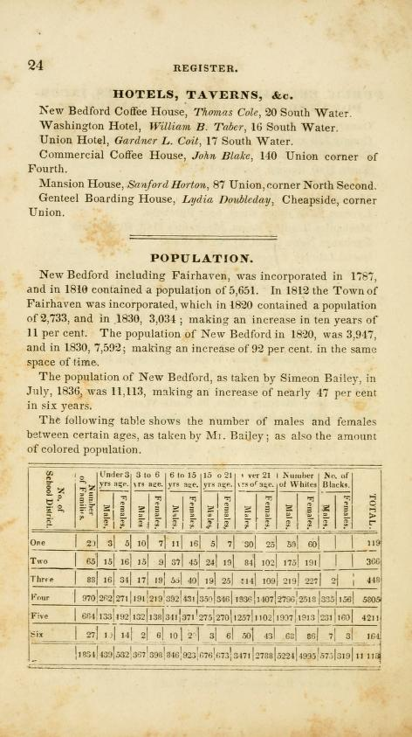
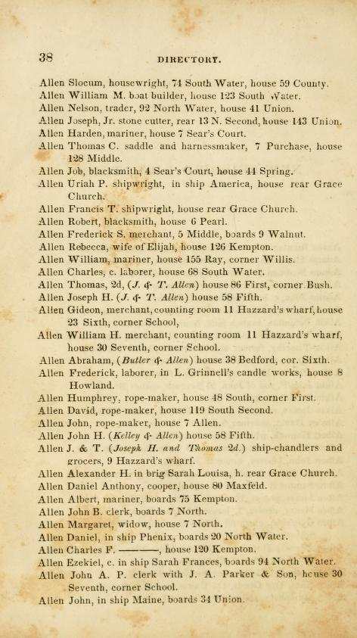
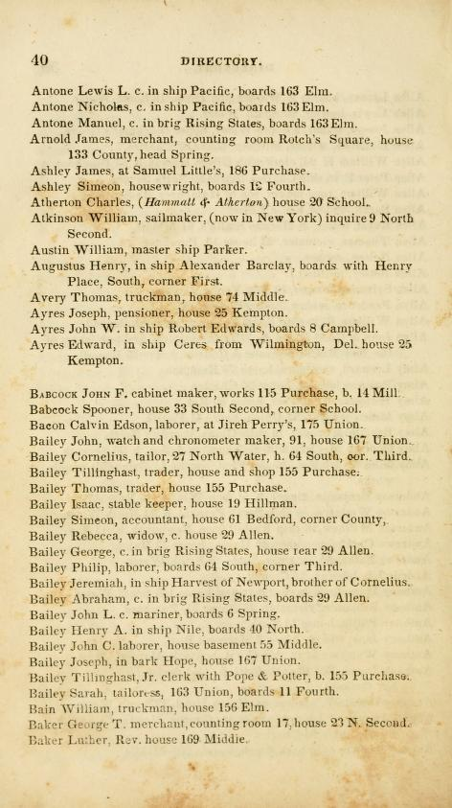
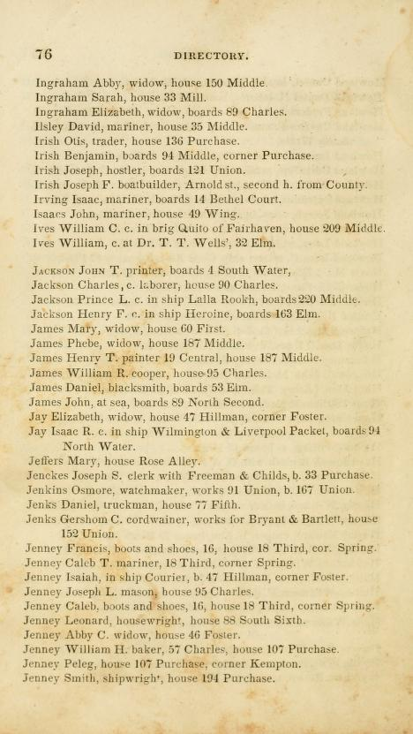
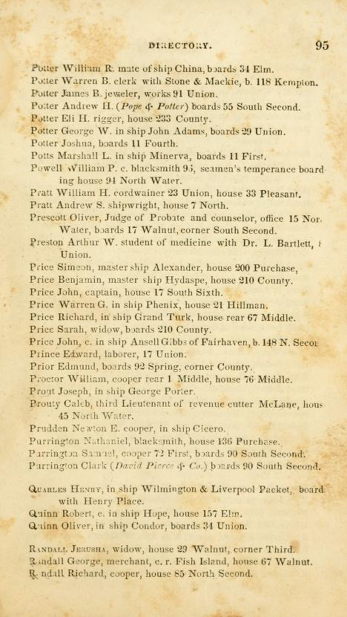
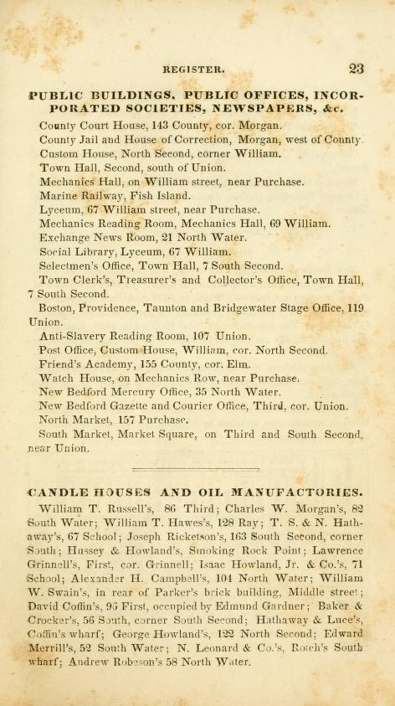

Document 2

Frederick Douglass Escape from Slavery

This is how the conversation went when the conductor reached Douglass in the crowded train car.
"I suppose you have your free papers?"
"No sir; I never carry my free papers to sea with me."
"But you have something to show that you are a freeman, haven't you?"
"Yes, sir, I have a paper with the American eagle on it, and that will carry me around the world."
A quick glance at the paper satisfied the conductor and he took Douglass's fare and went on to the other passengers. This moment was one of the most anxious Douglass had ever experienced. What do you think would have happened if the conductor had looked carefully at the paper?
If the conductor had looked closely, he would have noticed that Douglass did not match the description of the person on the form and he would have been required to send him back to slavery in Baltimore. Not only would this have been terrible for Douglass but also the friend, from whom he borrowed the Seaman's Certificate, would have been in serious trouble. Later, when Douglass wrote his first autobiography in 1845, he didn't include the way in which he escaped because some of the people who had helped him could have gotten into trouble. This song cover shows a made-up description of the way Douglass escaped. By the time Douglass wrote his revised autobiography in 1881, he included the real description of his daring escape.

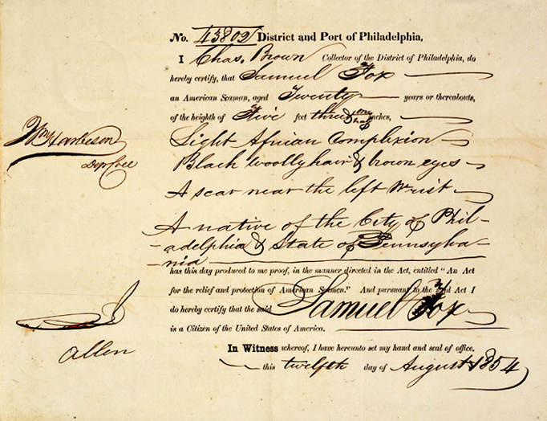
Seaman’s Protection Certificate

